Mallorca: Cultura y Playas
September 1-10: 10 days of sunny island exploration with La Única
A jewel of the Mediterranean, Mallorca is a top vacation spot for Europeans and of growing fascination to the rest of the world! Together we will pull back the curtain on the island, emphasizing the deep history and culture of the Islas Baleares. Meanwhile, we’ll revel in the company of spectacular beaches, unique gastronomy, and picturesque mountain towns. Take a more local look at this globally cherished island with us. Our exciting itinerary:
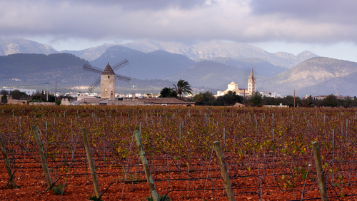
Día 1) Fly from Madrid to Palma and get settled into the lovely hotel. Take some time to rest and then reunite for the opening dinner. *NOTE: Travelers are to make their own international flight arrangements, as the trip package starts from Madrid and is not part of the cost.
Día 2) Enjoy breakfast and prepare to dive into the capital of Mallorca. Palma is a charming area with a must-see casco antiguo (old town) which we will tour, offering sights of Gothic churches, scenic squares, and bustling plazas. Additionally, we’ll enter Palma’s iconic cathedral ‘La Seu’. Lunch will include the scrumptious Spanish dishes you’ve been dreaming about, and in the evening, you’ll have time to roam shops and bars. Palma is luminous by night!
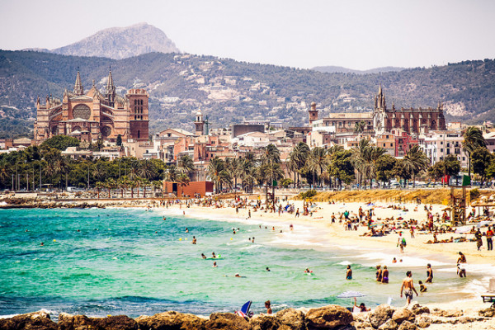
Día 3) Wine route! We embark on an excursion to Mallorca’s wine region in the island’s interior. We’ll take part in a bodega tours and wine tastings in Binissalem, which is a locality rewarded with its own Denominació d'Origen (Denomination of Origin). Here in Binissalem we’ll have a meal of traditional Mallorcan delicacies.

Día 4) Take some time to relax and enjoy the sun and sand on any of the many accessible beaches in Palma or feed your curiosity in local museums.
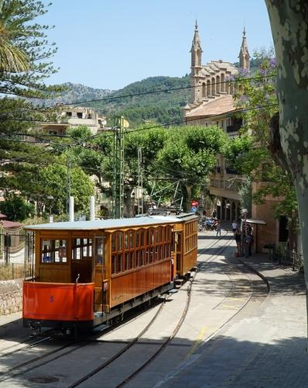
Día 5) We’ll make our way to Sóller, an enchanting mountain town of unique origin. In the 19th century, money was made by exporting Sóller’s abundant citrus. Locals who brought their oranges to France returned with riches that were poured into sophisticated villas in Spain’s local adaptation of the Art Nouveau style,the modernista. Sóller was known as the ‘City of Oranges’ and ‘City of Gold.’ The best part? Transportation there is via the traditional Ferrocarril (railway) which boasts scenic views through the mountain range, the Serra de Tramuntana.

Día 6) We’ll start with a leisurely coffee and mallorcan treat of ensaimadas in Sóller’s social and festive town square, La plaza de la constitución. Then we will take an excursion to the picturesque village of Valldemossa and the mystical cape of Deià, which has captured the attention and hearts of numerous creative and famous figures throughout the years. Dinner back in Sóller’s will allow us an opportunity to enjoy fresh mediterranean cuisine.

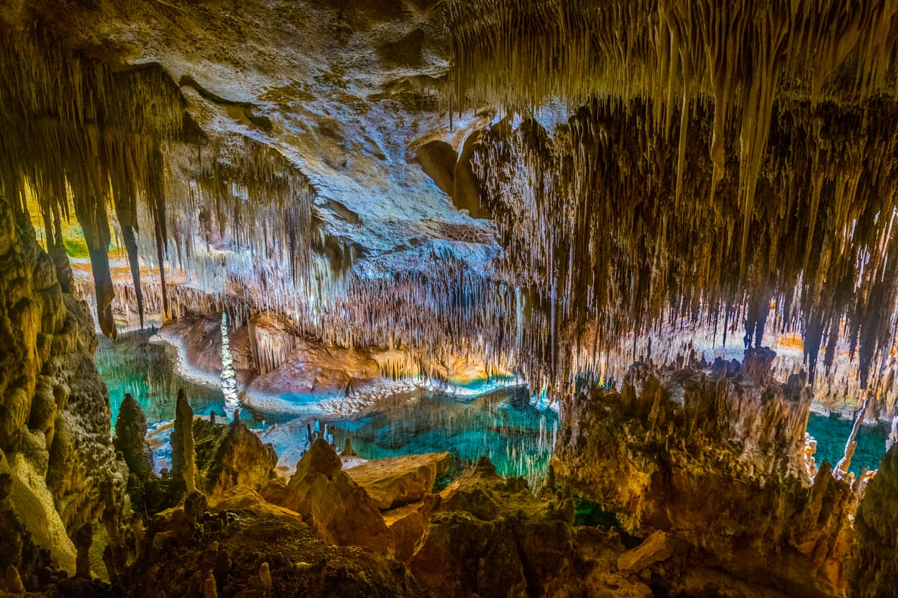
Día 7) We go east to Alcúdia, where the beaches are known as some of the best in Spain. White sands and turquoise waters. Along the shore, you’ll have the chance to gape at some of the modern yachts that invade the marinas. Then we’ll go back in time to visit la ciudad amurallada (the walled city) of Alcúdia, which still hosts original Roman ruins from centuries past. We’ll enjoy another fabulous lunch and some time on the sea.

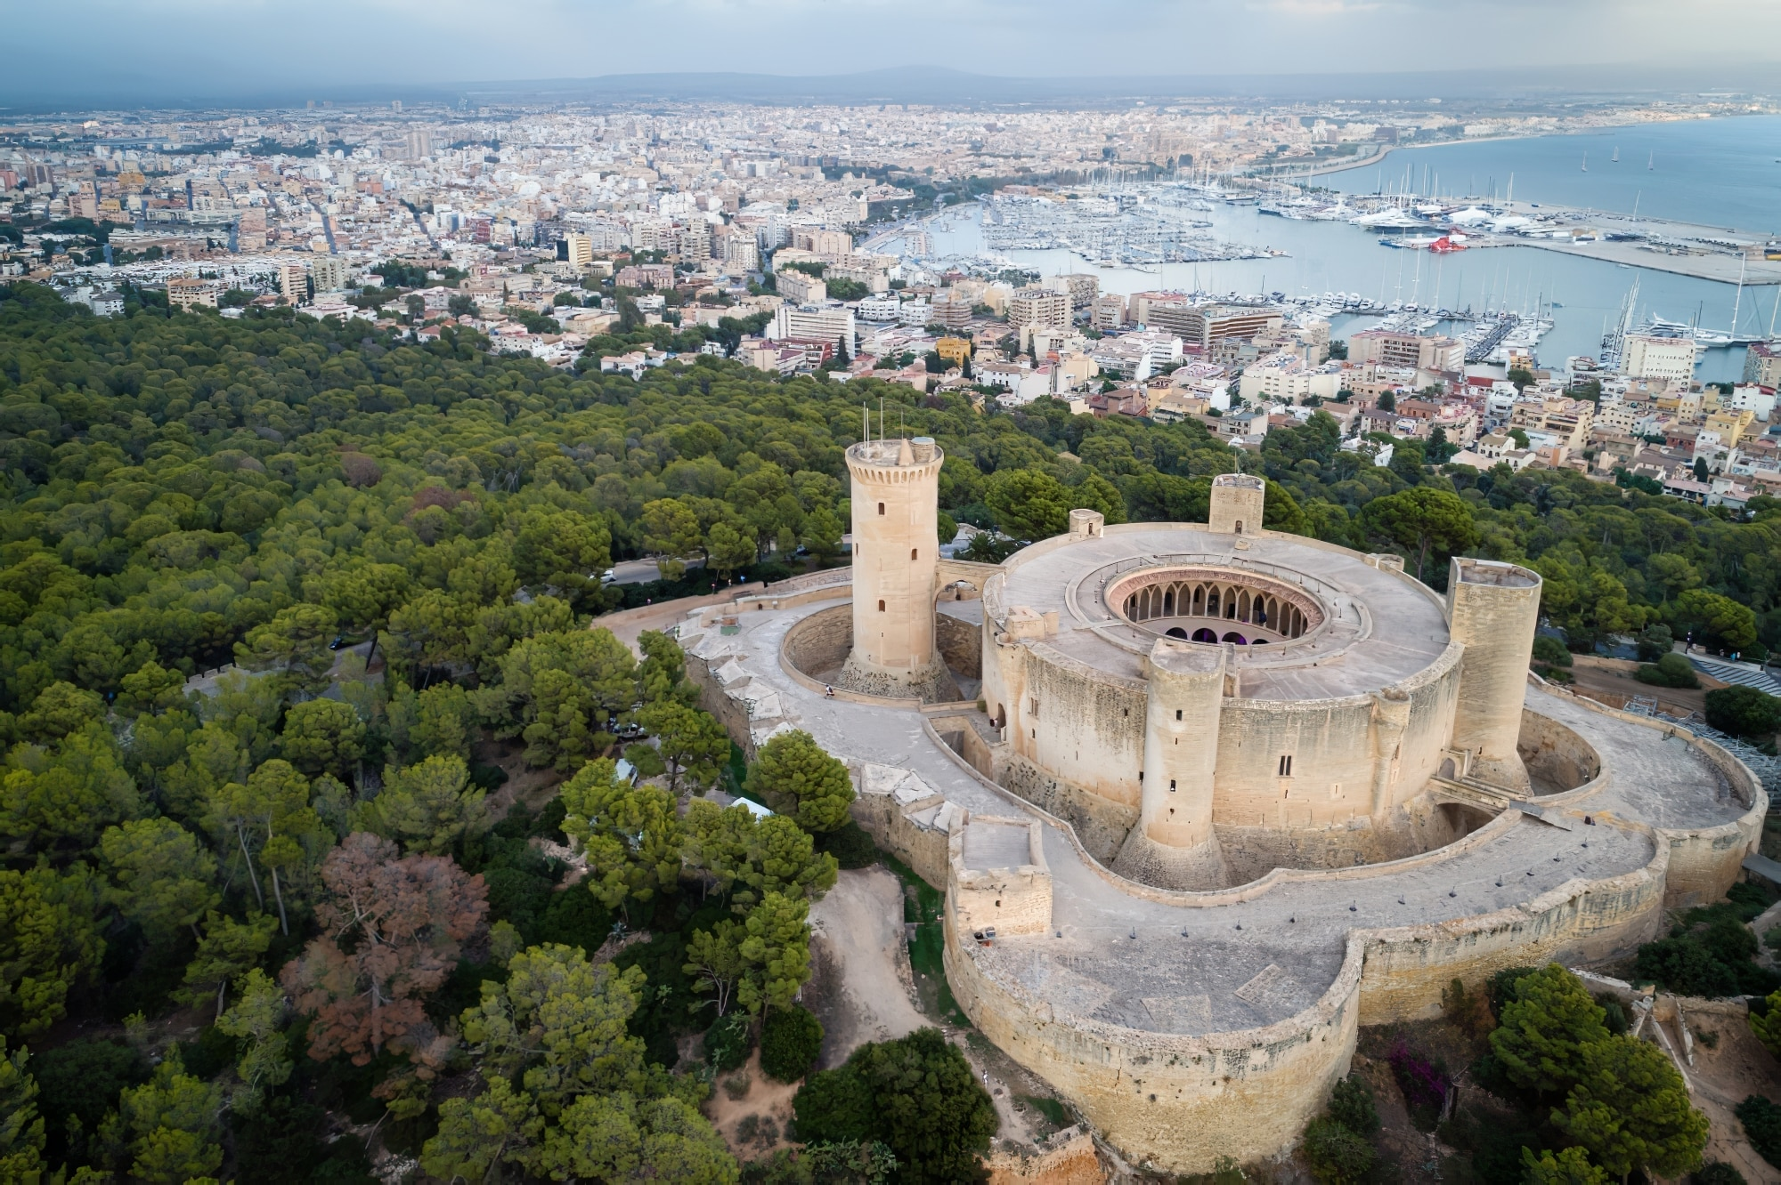
Día 8) Prepare for other-worldly scenery during our visit to Las cuevas del drach: The dragon caves. Taking their name from Mallorcan folklore, these caves mystify in natural beauty and are said to have inspired Jules Verne's science-fiction novel, Journey to the Centre of the Earth. From there, we will journey back to Palma.

Día 9) Our last full day on-island will begin with breakfast and a visit to the emblematic Castell de Bellver. Bellver means ‘lovely view’ in Mallorcan and the 14th-century royal fortress lives up to its name by granting us the most privileged view of the city and bay. In the afternoon we’ll toast to our experience at a local gin distillery, with gin distilled with foraged wildflowers and fresh citrus fruit from the rural orchards of Mallorca.

Día 10) A lovely group breakfast before our afternoon sendoff. Time to plan our after-trip fiesta!

Registration / Sign-up for:

Mallorca Cultura y Playas con La Única

1-10 September 2024

$3695
*Please include your $500 deposit with your registration
*Unless we cancel the trip, this is nonrefundable

*See below for payment plan and all that is included in the trip price.
Full Name: _________________________________________________
Address: ___________________________________________________
Home Phone: _______________________________________________
Alternate Contact Numbers: __________________________________
Date of Birth: _______________________________________________
Email: _____________________________________________________
Emergency Contact (name and contact numbers of a friend or family member
we can contact in case of an emergency): ___________________________
_____________________________________________________________
U.S. Passport Number: _________________________________________
*Please provide a photocopy of your passport with your registration form*
Do you have any health conditions or issues we should know about?

Please chose and circle your selected payment plan:
($500 sign-up deposit): Trip total = $3695
full payment $3695 upon sign-up Includes your $500 deposit.
2-payments (after deposit): $1597.5 on or by 1/15/24 and 6/30/24
3-payments (after deposit): $1065 on or by: 1/15/24, 4/15/24 & 7/15/24
Accepted method of payments: check, money-order, cash, Zelle, credit card (3.8% processing fee). Checks and money orders should be made out to: La Única.

$3695: Price of the trip includes:
- Domestic round-trip airfare: Madrid - Palma de Mallorca & Palma de Mallorca - Madrid**
- Hotel stays (based on double-occupancy).
If you want a single room, it will be $75 more PER NIGHT.
- All airport & hotel transfers plus
- All excursion/tour transports
- Meals: All breakfasts, 7 nice group meals (¨comida¨ o cena).
- Excursions, tours & private guides
- 3-4 Informational group meetings
**Not included: International round-trip airfare, tipping, personal items and all else not listed above.

